Task 1

Study and usage of OpenProj or similar software to draft a project plan.

Project managers can use OpenProj, a free project tracking application, when creating Effective project plans. OpenProj delivers functionality that rivals the capabilities of commercial software. This can save a project thousands of dollars in start up costs. Of course, saving a lot of money canbe foolish if the project tasks can't be done. This is not the case with OpenProj. Luckily the OpenProj application gives project managers a full set of tools that are typically used by project managers to track projects. Useful aids such as critical path analysis, resource tracking and task comments are all present in Open- Proj. The tool is ideal for simple project management but is capable of large efforts as well.
The best way to understand how a project plan may be created using OpenProj is to study a realistic example such as the one below. This example, while simple, provides a step by step description of typical actions that a project manager might use to establish a viable project plan using OpenProj. You are encouraged to try a similar example on your own.
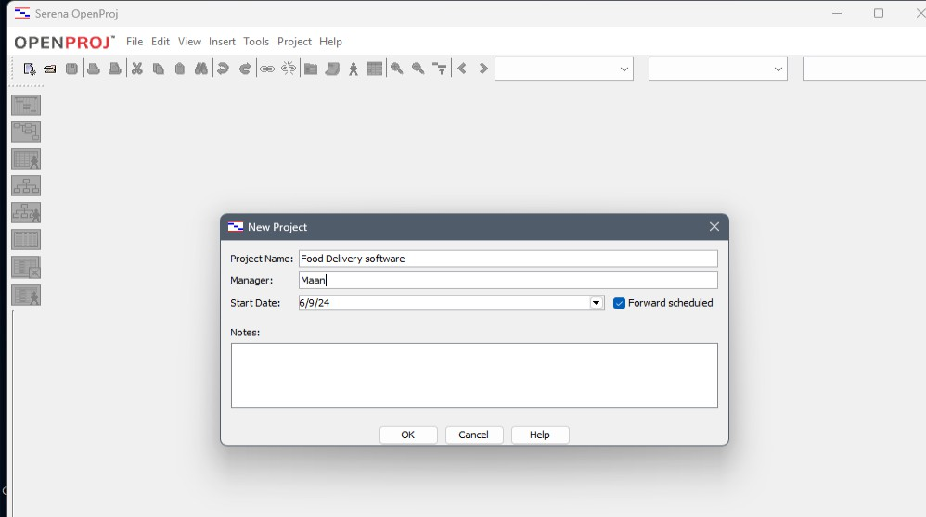
Figure 1.1-Openproj

Usage of OpenProj
OpenProj is an open-source project management software application that is designed to help users plan, manage, and track projects. It provides a range of features and tools to assist with project management tasks. Some of the common uses of OpenProj are given below

- Project Planning: OpenProj allows users to create project plans by defining tasks, assigning resources, setting dependencies, and establishing timelines. It provides Ganttcharts and other visual tools to help with project scheduling.
- Task Management: Users can create, edit, and manage individual tasks within a project. Tasks can be assigned to team members, and priorities and deadlines can be set.

- Resource Management: OpenProj helps in allocating and managing project resources ,including personnel, equipment, and materials. Users can track resource availability and workload.
- Gantt Charts: The software offers Gantt charts that provide a visual representation of the project schedule. This helps user to understand task dependencies, critical paths, and project milestones.
- Cost Tracking: OpenProj allows users to track project costs by assigning resource costs and estimating expenses. It can calculate project costs based on resource rates and actual work completed.
- Reporting: Users can generate various reports and project status updates, including task lists, resource allocation reports, and progress reports. This helps in keeping stake holders informed about the project's status
- Collaboration: OpenProj supports collaboration among team members by allowing them to share project files and update project data in real-time. This can be useful for distributed teams.
- Risk Management: Some versions of OpenProj may include features for managing project risks and issues, enabling users to identify, assess, and mitigate potential problems.
- Integration: OpenProj may offer integration with other project management and business software, allowing users to import/export data, connect to databases, or integrate with accounting and CRM systems.
- Portfolio Management: In some cases, OpenProj can be used for managing a portfolio of projects, helping organizations prioritize and allocate resources across multiple projects.
- Learning and Training: OpenProj can be used as a tool for teaching project management principles and techniques in educational settings.
- Non-profit and Small Business Management: Non-profit organizations and small businesses with limited budgets may find OpenProj to be a cost-effective solution for managing their project.

For the purpose of the example of project plan the following assumption are made:

Step 1: Create the project plan shell:-The first step is to use OpenProj to identify the basic parameters of the project. The project manager starts the OpenProj application and presses the "Create Project" button. The project is named, ("News Shower"), and a starting date is given. You can forward schedule a project which is the default. This allows you to enter the required tasks and OpenProj will calculate a completion date. If required, you can schedule a finish date and have OpenProj work backwards for you. This alternate method works best if there is a hard drop-dead date, such as a launch date. The project manager can also add initial project notes. These might refer to locations of project initiation documentation or other optional information.

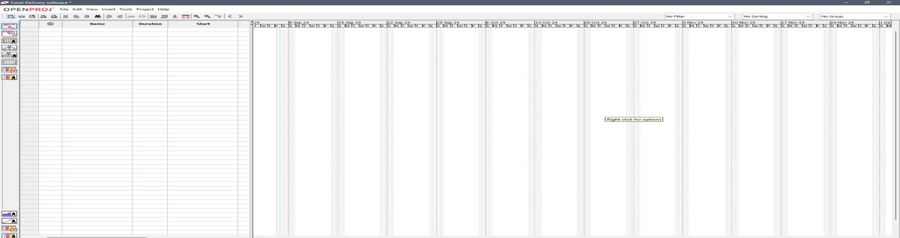
Figure 1.2-Particulars of Project pla
Step 2: Identify the project resources:-Use the resources view to enter the particulars of all of the project team. The names and roles of the team members can be specified. If required, you can enter hourly rates, overtime and availability Information for each team member. For this example, three 100% resources will be entered
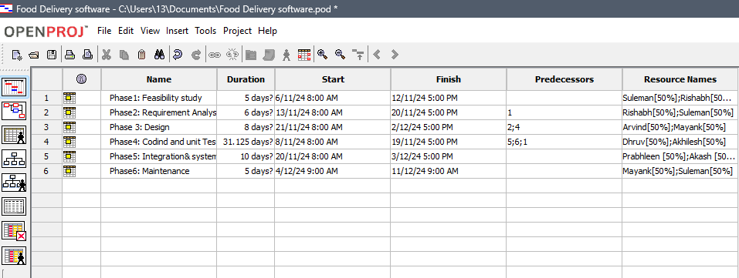

Figure 1.3- Project Assignment
Step 3: Identify the project's high-level tasks:-For this example, the project is similar to an earlier project that was completed successfully. Thatproject required tasks for initiation, research, contracting, development and launch. The project manager enters these tasks into the Gantt view of OpenProj. The duration estimates are based onthe values previously seen for similar tasks. There is no ordering of tasks or dependencies. The raw Gantt list is below
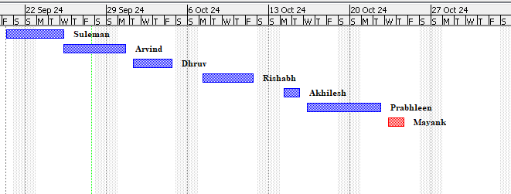
Figure 1.4- Task Assigning
Notice that the task "Application Development" is shown with a red duration bar while All other tasks have blue bars. This task is identified as the project critical path. It is the longest

running task in the project. Since all tasks default to the start date of the project, the analysis of the critical path is quite premature at this time. The project manager must now modify dependencies.

Step 4: Identify the task dependencies:- During a project, some tasks can't start until others have been completed. This is true for the project's "Test launch" task. There is nothing to test until the development is completed. As well, the "News Shower" launch is dependent on every other task. The project manager, in discussions with team members or sponsors as appropriate, determines the task dependencies. The modified Gantt view now shows a realistic project schedule.
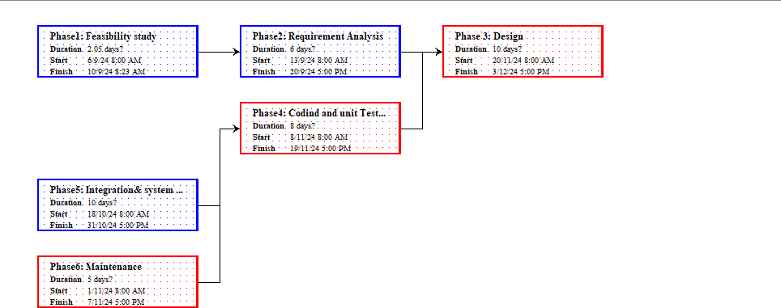

Figure –Task Dependencies
Step 5: Assign project resources to tasks:- Each of the tasks can have one or more resources assigned. The column "Resource Names" on the Gantt View allows direct data entry of this information. Enter the name of a resource in the field. The default action is to have each named resource work 100% of their time on the task. The field also supports the direct entry of multiple resources. Enter the resource names separated by a semi- colon.
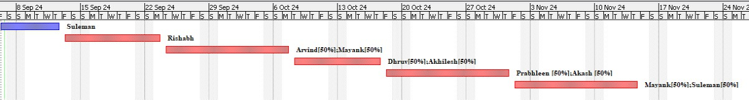
Figure 1.6- Resource assigning
Step 6: Task elaboration:- An important feature of project management applications is the ability to allow the project manager to split tasks into smaller sub-tasks. This can allow better accuracy in schedule estimating. It also allows team members to be specified in a just-in-time fashion for their assignments. The example project has some opportunities for task elaboration.

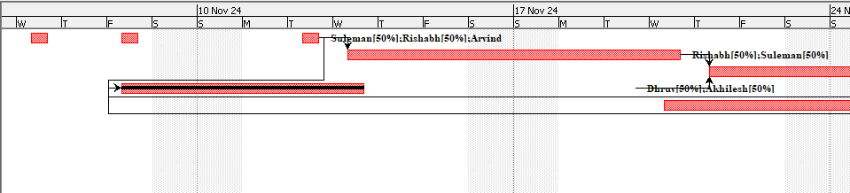

Figure-1.7 Task elaboration
Step 7: Evaluate the project plan:- With all of the tasks entered, and sub-tasks specified, the project plan has really evolved. It now shows a lot of information which can be useful in project reporting. The first item is the critical path. This of the highest importance to the project manager and the organization. Reports showing the tasks can be presented to company executives. An analysis of work loads can be done. Task reports can be printed. In time, as completion percentages are entered for tasks, the project manager can run status reports showing progress and schedule tracking.
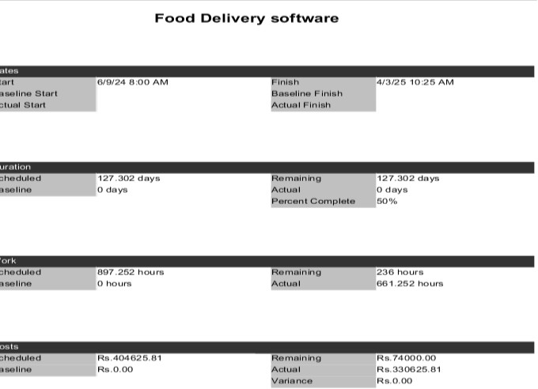
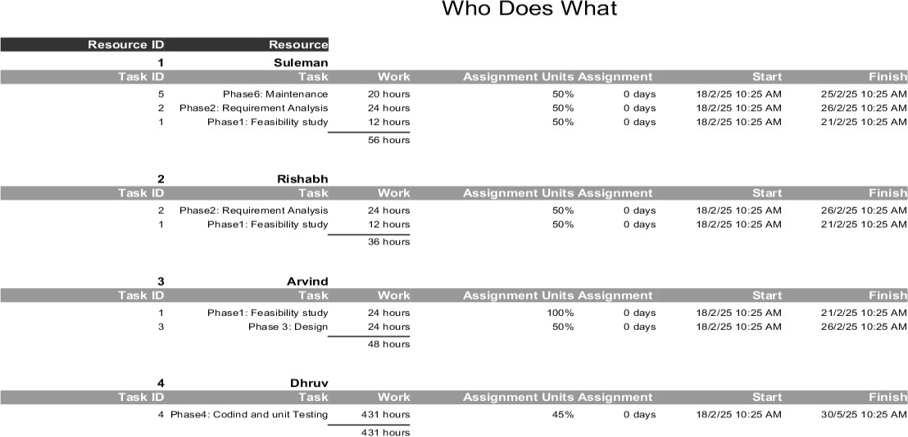

Figure 1.8 Evaluation of project

Task 2

Study and usage of OpenProj or similar software to track the progress of a project.

An effective project manager needs to ensure that the project goals are met on time and are within the budget. Anticipating the implications of a task that is slipping behind schedule, revising project plans, reassigning resources and finding ways to minimize the impact on time and costs require an orderly approach to tracking project progress. Once your plan is set up and your resources assigned, you are ready to start your project. This brings you to a different set of Project features, which can help you track your progress and compare this progress to your original plan. In this article, we’ll examine the following methods of tracking progress:
- Baselines
- Status using percent complete
- Status using actual work hour

Using Baselines:
After you have your resources leveled and everything is set to begin, you might want to baseline your project. Baseline is a common project management term. It refers to a set of data about your project that represents its state before the work actually began. In Project, a baseline is a copy of the Start, Finish, Work, and Cost for all the Resources and Assignments, plus Duration for all the Tasks in your project. Together, this data represents the state of your plan at the time the baseline is saved.
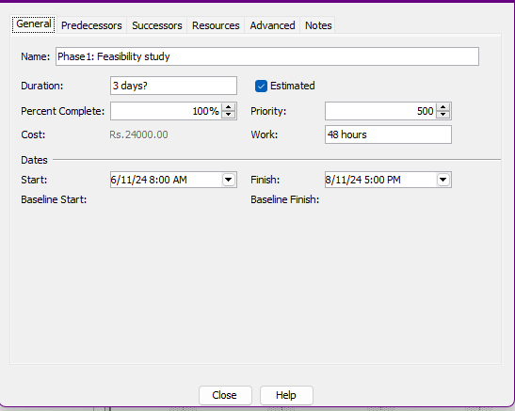
Figure 2.1 Baseline

Using percent complete and actual work done:
There are two commonly used methods of updating a project plan in Project with the status of your project work. The first uses percent complete to take a general measure of how “finished” a task or assignment is. The second uses a collection of actual work done by resources. The percent complete method is faster than the actual work method, but it gives a much more general, higher-level view of status. The actual work method takes a bit more time and requires more detailed communication between the project manager and the

resources, but it also provides much more detailed information about where the work is being done and where trouble might be.
  - Percent complete:The percent complete method uses the general feelings of the resource or the project manager about how complete an assignment or task is. You are asking your resource to tell you what percentage of the work is complete. You then enter this information into the Resource Usage view by adding in the Percent Work Complete field.
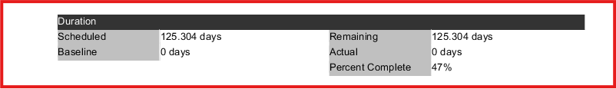

Figure 2.2 Percent completion
  - Actual work: The actual work method is basically the same as percentage complete, except it offers more detail. The actual work approach is normally used when a resource uses a timecard to track how many hours are spent working on each task for a given time period. Depending on our processes, these could be daily or weekly time periods. The reporting of the work done for these time periods is typically handled on a weekly basis. So every Friday, your resources turn in some kind of document that tells you how many hours they spent on each task per day or for the whole week. Again, the Resource Usage view is typically where the project manager enters this information. This view allows you to enter actual work on a time-period-by-time-period basis. So if you ask your resources to submit their actual work on their tasks day-by-day, you can set up the view to display Actual Work.
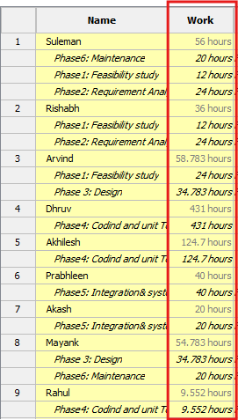
Figure 2.3 Actual work

Gantt chart
A Gantt chart is a horizontal bar chart developed as a production control tool in 1917 by Henry L. Gantt, an American engineer and social scientist. Frequently used in project management, a Gantt chart provides a graphical illustration of a schedule that helps to plan, coordinate, and track specific tasks in a project.A Gantt chart is constructed with a horizontal axis representing the total time span of the project, broken down into increments (for example, days, weeks, or months) and a vertical axis representing the tasks that make up the

project (for example, if the project is outfitting your computer with new software, the major tasks involved might be: conduct research, choose software, install software).
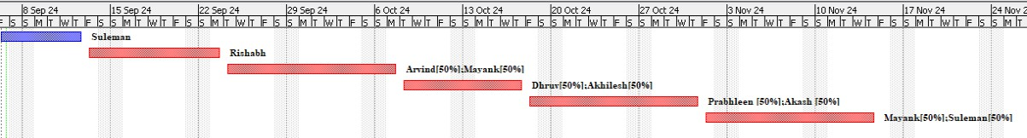
Figure 2.4- Gantt Chart

PERT chart
A PERT chart is a project management tool used to schedule, organize, and coordinate tasks within a project. PERT stands for Program Evaluation Review Technique, a methodology developed by the U.S. Navy in the 1950s to manage the Polaris submarine missile program. A PERT chart presents a graphic illustration of a project as a network diagram consisting of numbered nodes (either circles or rectangles) representing events, or milestones in the project linked by labelled vectors (directional lines) representing tasks in the project. The direction of the arrows on the lines indicates the sequence of tasks.
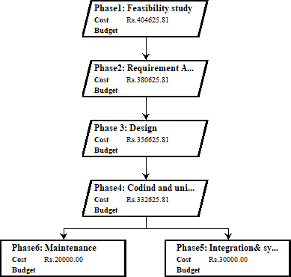
Figure 2.5 Pert chart

Critical Path Method (CPM):-
The critical path method (CPM) is an algorithm for scheduling a set of project activities. It is an important tool for effective project management. The essential technique for using CPM is to construct a model of the project that includes the following:
- A list of all activities required to complete the project (typically categorized within a work breakdown structure ).
- The time (duration) that each activity will take to complete.
- The dependencies between the activities.
- Logical end points such as milestones or deliverable items.

Task 3

Preparation of Software Requirement Specification Document, Design Documents and Testing Phase.
Software Requirement Specification (SRS) Format as the name suggests, is a complete specification and description of requirements of the software that need to be fulfilled for the successful development of the software system. These requirements can be functional as well as non-functional depending upon the type of requirement. The interaction between different customers and contractors is done because it is necessary to fully understand the needs of customers.

Introduction To Software Requirement Specification
  - Purpose of this Document – At first, main aim of why this document is necessary and what’s purpose of document is explained and described.
  - Scope of this document – In this, overall working and main objective of document and what value it will provide to customer is described and explained. It also includes a description of development cost and time required.
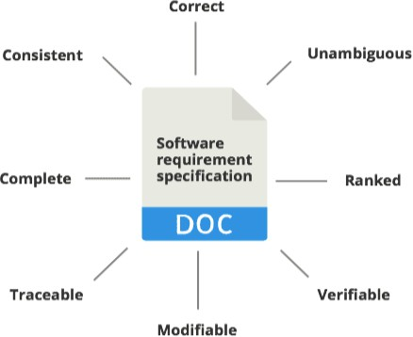
  - Overview – In this, description of product is explained. It’s simply summary or overall review of product.

Figure 3.1 SRS

Design Documents
Design documents detail the architecture and design of the system. They help in understanding how the system will be built. Key components include:
  - High-Level Design (HLD): Describes the system architecture, data flow, and high-level components.
  - Low-Level Design (LLD): Provides detailed descriptions of each module, including algorithms, data structures, and interface details.
  - UML Diagrams: Use case diagrams, class diagrams, sequence diagrams, and activity diagrams to visually represent the system.

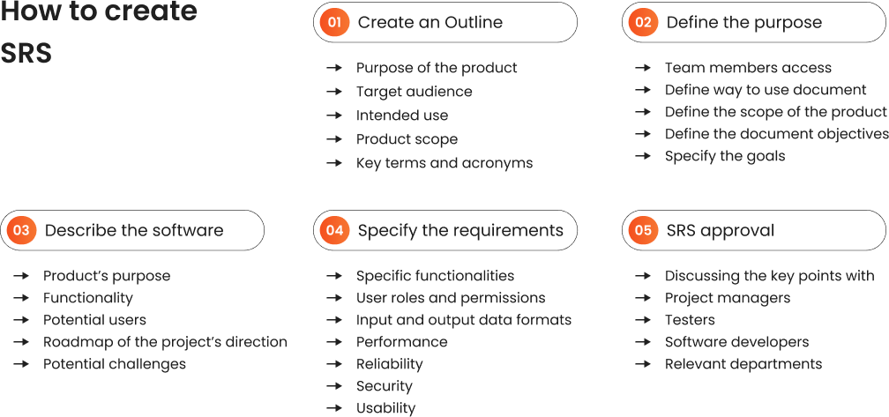

Figure 3.2 SRS Design

Testing Phase
The testing phase ensures that the software meets the specified requirements and is free of defects. Key activities include:
  - Test Plan: This outlines the overall strategy for testing the software, including the scope, objectives, resources, schedule, and activities involved in the testing process.
  - Test Scenarios: These are high-level descriptions of what to test. They provide a broad overview of the testing requirements and help ensure that all functional and non-functional requirements are covered.
  - Test Cases: Detailed steps that describe how to test a specific functionality or feature. Each test case includes inputs, execution conditions, and expected results.
  - Test Data: The data that will be used during testing. This can include both valid and invalid data to ensure the software handles all possible inputs correctly.
  - Traceability Matrix: A document that maps and traces user requirements with the test cases. This ensures that all requirements are covered by test cases and helps in identifying any missing requirements.
  - Acceptance Criteria: The conditions that must be met for the software to be accepted by the stakeholders. This includes both functional and non-functional requirements.

Task 4

Preparation of Software Requirement Specification related documents for some problems.

A Software Requirements Specification (SRS) is a document that describes the nature of a project, software or application. In simple words, an SRS document is a manual of a project provided it is prepared before you kick-start a project/application. This document is also known by the names SRS report, or software document. A software document is primarily prepared for a project, software, or any kind of application.
There are a set of guidelines to be followed while preparing the software requirement specification document. This includes the purpose, scope, functional and non-functional requirements, and software and hardware requirements of the project. In addition to this, it also contains information about environmental conditions required, safety and security requirements, software quality attributes of the project, etc.

What is a Software Requirements Specification document?
A Software requirements specification document describes the intended purpose, requirements and nature of a software to be developed. It also includes the yield and cost of the software.
In this document, flight management project is used as an example to explain few points.
- INTRODUCTION

PURPOSE
The purpose of this document is to build an online system to manage flights and passengers to ease the flight management.

DOCUMENT CONVENTIONS
This document uses the following conventions. <<Include the conventions as per your application >>

DB | Database
DDB | Distributed Database
ER | Entity Relationship

INTENDED AUDIENCE AND READING SUGGESTIONS
This project is a prototype for the flight management system and it is restricted within the college premises. This has been implemented under the guidance of college professors. This project is useful for the flight management team and as well as to the passengers.

PROJECT SCOPE
The purpose of the online flight management system is to ease flight management and to create a convenient and easy-to-use application for passengers, trying to buy airline tickets. The system is based on a relational database with its flight management and reservation functions. We will have a database server supporting hundreds of major cities around the world as well as thousands of flights by various airline companies. Above all, we hope to provide a comfortable user experience along with the best pricing available.

OVERALL DESCRIPTION

PRODUCT PERSPECTIVE
A distributed airline database system stores the following information.

Flight details:
It includes the originating flight terminal and destination terminal, along with the stops in between, the number of seats booked/available seats between two destinations etc.

Customer description:
It includes customer code, name, address, and phone number. This information may be used for keeping the records of the customer for any emergency or for any other kind of information.

Reservation description:
It includes customer details, code number, flight number, date of booking, date of travel.

PRODUCT FEATURES
The major features of the airline database system as shown in below entity–relationship model (ER model).
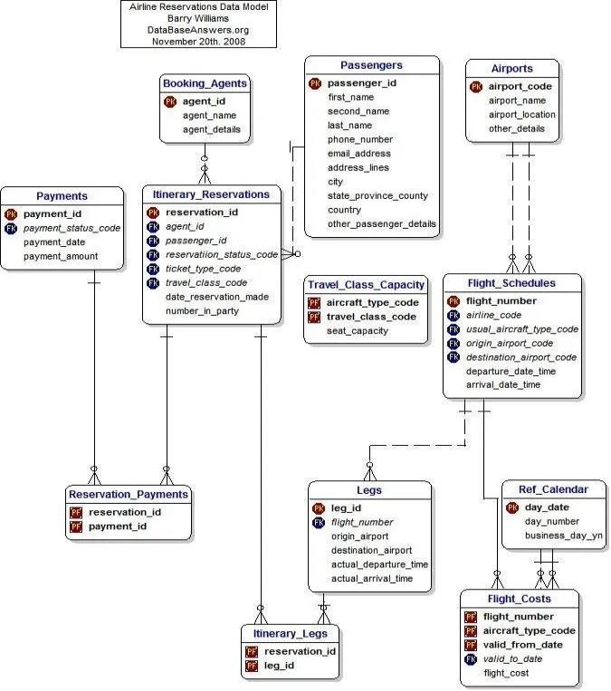
Figure 4.1 E-R diagram

USER CLASS and CHARACTERISTICS
Users of the system should be able to retrieve flight information between two given cities with the given date/time of travel from the database. A route from city A to city B is a sequence of connecting flights from A to B such that: a) there are at most two connecting stops, excluding the starting city and destination city of the trip, b) the connecting time is between one to two hours. The system will support two types of user privileges, Customer, and Employee. Customers will have access to customer functions, and the employees will have access to both customer and flight management functions. The customer should be able to do the following functions:

Make a new reservation
- One-way
- Round-Trip
- Multi-city
- Flexible Date/time
- Confirmation

Cancel an existing reservation View his itinerary
The Employee should have the following management functionalities:

CUSTOMER FUNCTIONS.
- Get all customers who have seats reserved on a given flight.
- Get all flights for a given airport.
- View flight schedule.
- Get all flights whose arrival and departure times are on time/delayed.
- Calculate total sales for a given flight.

ADMINISTRATIVE
- Add/Delete a flight
- Add a new airport
- Update fare for flights.
- Add a new flight leg instance.
- Update departure/arrival times for flight leg instances.
Each flight has a limited number of available seats. There are a number of flights that depart from or arrive at different cities on different dates and times.

OPERATING ENVIRONMENT
The operating environment for the airline management system is as listed below.
    - distributed database
    - client/server system
    - Operating system: Windows.
    - database: sql+ database
    - platform: vb.net/Java/PHP

DESIGN and IMPLEMENTATION CONSTRAINTS
- The global schema, fragmentation schema, and allocation schema.
- SQL commands for the above queries/applications
- How the response for applications 1 and 2 will be generated? Assuming these are global queries. Explain how various fragments will be combined to do so.
- Implement the database at least using a centralized database management system.

ASSUMPTION DEPENDENCIES
Let us assume that this is a distributed airline management system and it is used in the following application:
    - A request for booking/cancellation of a flight from any source to any destination, giving connected flights in case no direct flight between the specified Source-Destination pair exist.
    - Calculation of high fliers (most frequent fliers) and calculating appropriate reward points for these fliers.
    - Assuming both the transactions are single transactions, we have designed a distributed database that is geographically dispersed at four cities Delhi, Mumbai, Chennai, and Kolkatta as shown in fig. below.

SYSTEM FEATURES

DESCRIPTION and PRIORITY
The airline reservation system maintains information on flights, classes of seats, personal preferences, prices, and bookings. Of course, this project has a high priority because it is very difficult to travel across countries without prior reservations.

STIMULUS/RESPONSE SEQUENCES
- Search for Airline Flights for two Travel cities
- Displays a detailed list of available flights and makes a “Reservation” or Books a ticket on a particular flight.
- Cancel an existing Reservation.
FUNCTIONAL REQUIREMENTS
Other system features include:

DISTRIBUTED DATABASE:
Distributed database implies that a single application should be able to operate transparently on data that is spread across a variety of different databases and connected by a communication network as shown in the below figure.

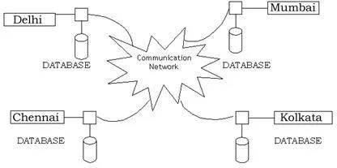

Figure 4.2 Distributed system

CLIENT/SERVER SYSTEM
The term client/server refers primarily to an architecture or logical division of responsibilities, the client is the application (also known as the front-end), and the server is the DBMS (also known as the back-end).
A client/server system is a distributed system in which,
- Some sites are client sites and others are server sites.
- All the data resides at the server sites.
- All applications execute at the client sites.

EXTERNAL INTERFACE REQUIREMENTS

USER INTERFACES
Front-end software: Vb.net version Back-end software: SQL+

HARDWARE INTERFACES
Windows.
A browser that supports CGI, HTML & Javascript.

SOFTWARE INTERFACES
Following are the software used for the flight management online application.

Software used | Description
Operating system | We have chosen Windows operating system for its best support and user-friendliness.
Database | To save the flight records, passengers records we have chosen SQL+ database.

VB.Net | To implement the project we have chosen Vb.Net language for its more interactive support.

COMMUNICATION INTERFACES
This project supports all types of web browsers. We are using simple electronic forms for reservation forms, ticket booking etc.

NONFUNCTIONAL REQUIREMENTS

PERFORMANCE REQUIREMENTS
The steps involved to perform the implementation of the airline database are listed below.

E-R DIAGRAM
The E-R Diagram constitutes a technique for representing the logical structure of a database in a pictorial manner. This analysis is then used to organize data as a relation, normalizing relation, and finally obtaining a relation database.
  - ENTITIES: These specify distinct real-world items in an application.
  - PROPERTIES/ATTRIBUTES: These specify properties of an entity and relationships.
  - RELATIONSHIPS: These connect entities and represent meaningful dependencies between them.
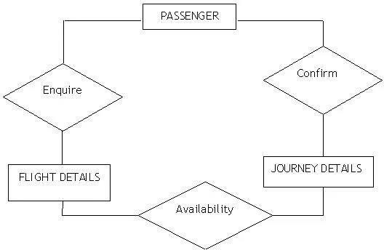

Figure 4.3 the diagram shows the ER diagram of the airline database

NORMALIZATION:
The basic objective of normalization is to reduce redundancy which means that information is to be stored only once. Storing information several times leads to a wastage of storage space and an increase in the total size of the data stored.

If a database is not properly designed it can give rise to modification anomalies. Modification anomalies arise when data is added to, changed, or deleted from a database table. Similarly, in traditional databases as well as improperly designed relational databases, data redundancy can be a problem. These can be eliminated by normalizing a database.
Normalization is the process of breaking down a table into smaller tables. So that each table deals with a single theme. There are three different kinds of modifications of anomalies and formulated the first, second, and third normal forms (3NF) is considered sufficient for most practical purposes. It should be considered only after a thorough analysis and complete understanding of its implications.

SAFETY REQUIREMENTS
If there is extensive damage to a wide portion of the database due to catastrophic failure, such as a disk crash, the recovery method restores a past copy of the database that was backed up to archival storage (typically tape) and reconstructs a more current state by reapplying or redoing the operations of committed transactions from the backed up log, up to the time of failure.

SECURITY REQUIREMENTS
Security systems need database storage just like many other applications. However, the special requirements of the security market mean that vendors must choose their database partner carefully.

SOFTWARE QUALITY ATTRIBUTES
    - AVAILABILITY: The flight should be available on the specified date and specified time as many customers are doing advance reservations.
    - CORRECTNESS: The flight should reach start from the correct start terminal and should reach the correct destination.
    - MAINTAINABILITY: The web application must support regular updates to ensure compatibility with the latest web technologies, Bug fixes, and security patches.
    - USABILITY: The flight schedules should satisfy a maximum number of customers’ needs. The application should be accessible on multiple devices, including desktop and mobile.

Task 5

Preparation of Software Configuration Management and Risk Management related documents.

Software Configuration Management The purpose of software configuration management is to plan, organize, control and coordinate the identification, storage and change of software through development, integration and transfer. Every project must establish a software configuration management system. Software configuration management must ensure that: software components can be identified:
- Software is built from a consistent set of components.
- Software components are available and accessible.
- Software components never get lost (e.g. after media failure or operator error).
- Every change to the software is approved and documented.
- Changes do not get lost (e.g. through simultaneous updates).
- It is always possible to go back to a previous version.
- A history of changes is kept, so that is always possible to discover who did what and when.

Project management is responsible for organizing software configuration management activities, defining software configuration management roles (e.g. software librarian), and allocating staff to those roles
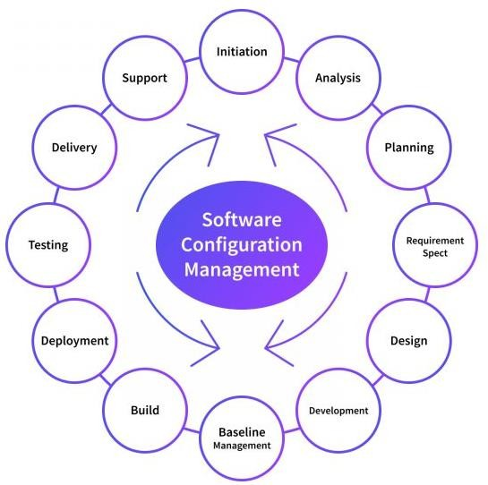
Figure 5.1 Software Configuration Management

Software Configuration Management Activities
The configuration management tool enables the developer to change various components in a controlled manner. Configuration management is carried out through two principal activities: Configuration identification involves deciding which parts of the system should be kept track of. Configuration control ensures that changes to a system happen smoothly.

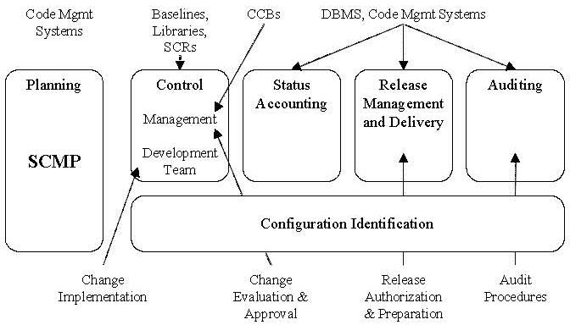
Figure 5.2 Software Configuration Management Activities
- Configuration identification: The first step in configuration management is to define the CIs and the conventions for their identification. The inputs to the configuration identification activity are the SPMP (which lists the project documents), the ADD and the DDD (which list the software components). These inputs are used to define the hierarchy of CIs. The output is a configuration item list, defining what will be built using the naming conventions described in the SCMP. The configuration item list physically defines the components to be developed and the baselines to be integrated.
- Configuration Control: Configuration item control authority should have a unique control authority that decides what changes will be made to a CI. The control authority may be an individual or a group of people. Three levels of control authority are normally distinguished in a software project:
  - Software author
  - Software project manager
  - Review board
Software Author: Software authors create low-level CIs, such as documents and code. Document writers are usually the control authority for draft documents. Programmers are normally the control authority for code until unit testing is complete. Software Project Manager: Software project managers are responsible for the assembly of high-level CIs (i.e., baselines and releases) from the low-level CIs provided by software authors. Software project managers are the control authorities for all these CIs. Low-level CIs are maintained in software libraries. On most projects, the software project manager is supported by a software librarian.
Review Board: The review board approves baselines and changes to them. During development phases, formal review of baselines is done by the UR/R, SR/R, AD/R, and DD/R boards. The review board is the control authority for all baselines that have been approved or are under review. The review board may decide that a baseline should be changed and authorizes the development or maintenance team to implement the change. Control authority rights are not returned. Those responsible for implementing changes must resist the temptation to make any changes that have not been authorized.

Risk
A risk is any anticipated unfavorable event or circumstance that can occur while a project is underway. Risks are future uncertain events with a probability of occurrence and a potential for loss.

Categories of risks:
- Schedule Risk: Project schedules can slip when project tasks and schedule release risks are not addressed properly. Schedule risks mainly affect the project and, ultimately, the company’s economy, potentially leading to project failure. Schedules often slip due to the following reasons:
  - Wrong time estimation
  - Resources are not tracked properly, including staff, systems, skills of individuals, etc.
  - Failure to identify complex functionalities and the time required to develop those functionalities
- Operational Risks: Operational risks involve the risk of loss due to improper process implementation, failed systems, or external events. Causes of operational risks include:
  - Failure to address priority conflicts
  - Failure to resolve responsibilities
  - Insufficient resources, No proper subject trainings
  - No resource planning and communication within the team
- Technical Risks: Technical risks generally lead to the failure of functionality and performance. Causes of technical risks include:
  - Continuous changing requirements
  - No advanced technology available or the existing technology is in its initial stages, Product complexity
  - Difficult project module integration
- Programmatic Risks: Programmatic risks are external risks beyond the operational limits. These uncertain risks are outside the control of the program and can include:
  - Running out of funds
  - Market development
  - Changing customer product strategy and priority
  - Government rule changes
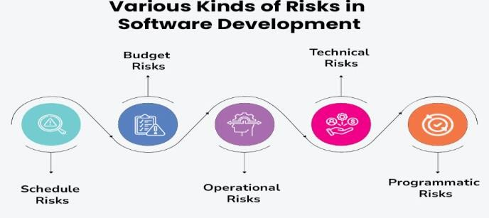
Figure 5.3- Risk

Risk management
Risk management is the identification, assessment, and prioritization of risks (followed by coordinated and economical application of resources to minimize, monitor, and control the probability and/or impact of unfortunate eventsor to maximize the realization of opportunities. The process of identification, analysis and either acceptance or mitigation of uncertainty in investment decision-making is called risk management. Essentially, risk management occurs anytime an investor or fund manager analyzes and attempts to quantify the potential for losses in an investment and then takes the appropriate action (or inaction) given their investment objectives and risk tolerance. Inadequate risk management can result in severe consequences for companies as well as individuals
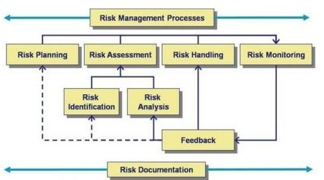
Figure 5.4- Risk Management
Risk Identification: The first step in the process of managing risk is to identify potential risks. Risks are about events that, when triggered, cause problems or benefits. Hence, risk identification can start with the source of our problems and those of our competitors (benefit), or with the problem itself.
- Source analysis- Risk sources may be internal or external to the system that is the target of risk management (use mitigation instead of management since by its own definition risk deals with factors of decision-making that cannot be managed). Examples of risk sources are: stakeholders of a project, employees of a company or the weather over an airport.

- Problem analysis- Risks are related to identified threats. For example: the threat of losing money, the threat of abuse of confidential information or the threat of human errors, accidents and casualties. The threats may exist with various entities, most important with shareholders, customers and legislative bodies such as the government. When either source or problem is known, the events that a source may trigger or the events that can lead to a problem can be investigated. For example: stakeholders withdrawing during.
When either source or problem is known, the events that a source may trigger or the events that can lead to a problem can be investigated. For example: stakeholders withdrawing during a project may endanger funding of the project; confidential information may be stolen by employees even within a closed network; lightning striking an aircraft during takeoff may make all people on board immediate casualties.

Risk Assessment: Once risks have been identified, they must then be assessed as to their potential severity of impact (generally a negative impact, such as damage or loss) and to the probability of occurrence. These quantities can be either simple to measure, in the case of the value of a lost building, or impossible to know for sure in the case of the probability of an unlikely event occurring. Therefore, in the assessment process it is critical to make the best educated decisions in order to properly prioritize the implementation of the risk management plan. The fundamental difficulty in risk assessment is determining the rate of occurrence since statistical information is not available on all kinds of past incidents. Furthermore, evaluating the severity of the consequences (impact) is often quite difficult for intangible assets. Asset valuation is another question that needs to be addressed. Thus, best educated opinions and available statistics are the primary sources of information.
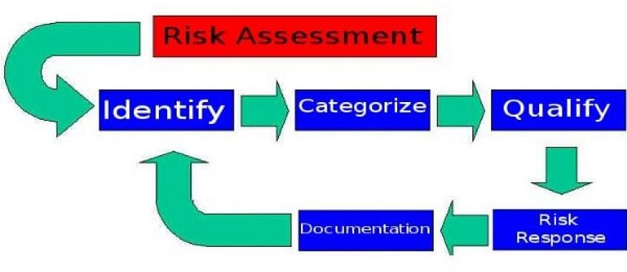
Figure 5.5 Risk assessement
Potential risk treatments: Once risks have been identified and assessed, all techniques to manage the risk fall into one or more of these four major categories:
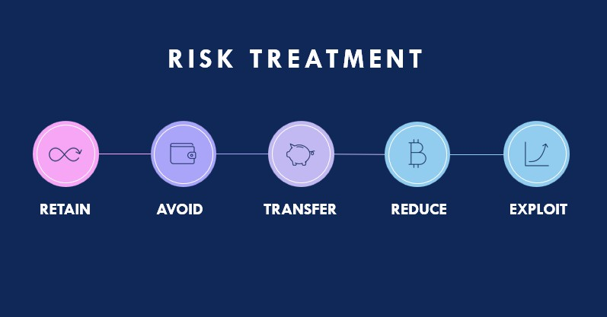
Figure 5.6 Risk Treatment

Risk avoidance: This includes not performing an activity that could carry risk. An example would be not buying a property or business in order to not take on the legal liability that comes with it. Another would be not flying in order not to take the risk that the airplane were to be hijacked .Avoidance may seem the answer to all risks, but avoiding risks also means losing out on the potential gain that accepting (retaining) the risk may have allowed. Not entering a business to avoid the risk of loss also avoids the possibility of earning profits. Increasing risk regulation in hospitals has led to avoidance of treating higher risk conditions, in favor of patients presenting with lower risk.

Risk reduction: Risk reduction or "optimization" involves reducing the severity of the loss or the likelihood of the loss from occurring. For example, sprinklers are designed to put out a fire to reduce the risk of loss by fire. This method may cause a greater loss by water damage and therefore may not be suitable. Halon fire suppression systems may mitigate that risk, but the cost may be prohibitive as a strategy.
Acknowledging that risks can be positive or negative, optimizing risks means finding a balance between negative risk and the benefit of the operation or activity; and between risk reduction and effort applied. By an offshore drilling contractor effectively applying HSE Management in its organization, it can optimize risk to achieve levels of residual risk that are tolerable. By developing in iterations, software projects can limit effort wasted to a single iteration.
Outsourcing could be an example of risk reduction if the outsourcer can demonstrate higher capability at managing or reducing risks. For example, a company may outsource only its software development, the manufacturing of hard goods, or customer support needs to another company, while handling the business management itself.

Risk sharing: It is defined as sharing with another party the burden of loss or the benefit of gain, from a risk, and the measures to reduce a risk.
The term of 'risk transfer' is often used in place of risk sharing in the mistaken belief that you can transfer a risk to a third party through insurance or outsourcing. In practice if the insurance company or contractor go bankrupt or end up in court, the original risk is likely to still revert to the first party. As such in the terminology of practitioners and scholars alike, the purchase of an insurance contract is often described as a "transfer of risk." However, technically speaking, the buyer of the contract generally retains legal responsibility for the losses "transferred", meaning that insurance may be described more accurately as a post-event compensatory mechanism. For example, a personal injuries insurance policy does not transfer the risk of a car accident to the insurance company. The risk still lies with the policy holder namely the person who has been in the accident. The insurance policy simply provides that if an accident (the event) occurs involving the policy holder then some compensation may be payable to the policy holder that is commensurate to the suffering/damage.

Some ways of managing risk fall into multiple categories. Risk retention pools are technically retaining the risk for the group, but spreading it over the whole group involves transfer among individual members of the group. This is different from traditional insurance, in that no premium is exchanged between members of the group up front, but instead losses are assessed to all members of the group.
Risk retention: Risk retention is a viable strategy for small risks where the cost of insuring against the risk would be greater over time than the total losses sustained. Involves accepting the loss, or benefit of gain, from a risk when it occurs. True self-insurance falls in this category. All risks that are not avoided or transferred are retained by default. This includes risks that are so large or catastrophic that they either cannot be insured against or the premiums would be infeasible. War is an example since most property and risks are not insured against war, so the loss attributed by war is retained by the insured. Also any amount of potential loss (risk) over the amount insured is retained risk. This may also be acceptable if the chance of a very large loss is small or if the cost to insure for greater coverage amounts is so great it would hinder the goals of the organization too much.

Task 6

Study and usage of any Design phase CASE tool.

Design Phase
Design phase starts with the requirement document delivered by the requirement phase and maps the requirements into an architecture. The architecture defines the components, their interfaces and behaviors. The deliverable design document is the architecture. The design document describes a plan to implement the requirements. This phase represents the ``how'' phase. Details on computer programming languages and environments, machines, packages, application architecture, distributed architecture layering, memory size, platform, algorithms, data structures, global type definitions, interfaces, and many other engineering details are established. The design may include the usage of existing components.

CASE Tools
CASE stands for Computer Aided Software Engineering. It means, development and maintenance of software projects with help of various automated software tools.
CASE tools are set of software application programs, which are used to automate SDLC activities. CASE tools are used by software project managers, analysts and engineers to develop software system.
There are number of CASE tools available to simplify various stages of Software Development Life Cycle such as Analysis tools, Design tools, Project management tools, Database Management tools, Documentation tools are to name a few.
Use of CASE tools accelerates the development of project to produce desired result and helps to uncover flaws before moving ahead with next stage in software development.
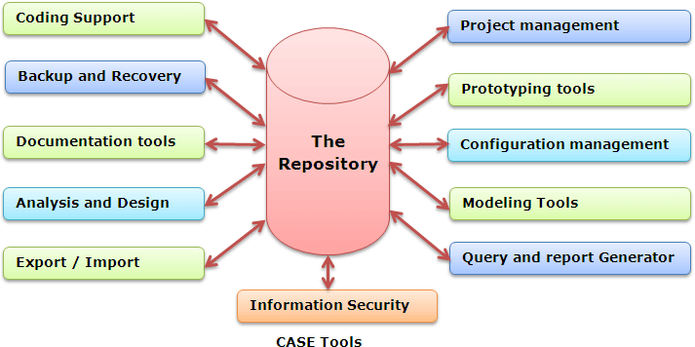
Figure 6.1- Case Tools

Components of CASE Tools
- Central Repository - CASE tools require a central repository, which can serve as a source of common, integrated and consistent information. Central repository is a central place of storage where product specifications, requirement documents, related

reports and diagrams, other useful information regarding management isstored. Central repository also serves as data dictionary
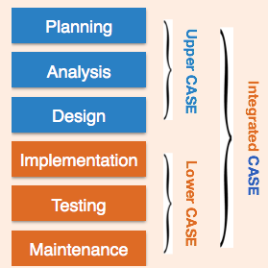
Figure 6.2- Components of case tool

- Upper Case Tools - Upper CASE tools are used in planning, analysis and design stages of SDLC.
- Lower Case Tools - Lower CASE tools are used in implementation, testing and maintenance.
- Integrated Case Tools - Integrated CASE tools are helpful in all the stages of SDLC, from Requirement gathering to Testing and documentation.

Scope of Case Tools
The scope of CASE tools goes throughout the SDLC.

Case Tools Types
Now we briefly go through various CASE tools

Diagram tools
These tools are used to represent system components, data and control flow among various software components and system structure in a graphical form. For example, Flow Chart Maker tool for creating state-of-the-art flowcharts.

Process Modelling Tools
Process modelling is method to create software process model, which is used to develop the software. Process modelling tools help the managers to choose a process model or modify it as per the requirement of software product. For example, EPF Composer.

Project Management Tools
These tools are used for project planning, cost and effort estimation, project scheduling and resource planning. Managers have to strictly comply project execution with every mentioned step in software project management. Project management tools help in storing and sharing project information in real-time throughout the organization. For example, Creative Pro Office, Trac Project, Basecamp.

Documentation Tools
Documentation in a software project starts prior to the software process, goes throughout all phases of SDLC and after the completion of the project.
Documentation tools generate documents for technical users and end users. Technical users are mostly in-house professionals of the development team who refer to system manual, reference manual, training manual, installation manuals etc. The end user documents describe the functioning and how-to of the system such as user manual. For example, Doxygen, DrExplain, Adobe RoboHelp for documentation.

Analysis Tools
These tools help to gather requirements, automatically check for any inconsistency, inaccuracy in the diagrams, data redundancies or erroneous omissions. For example, Accept 360, Accompa, Case Complete for requirement analysis, Visible Analyst for total analysis.

Design Tools
These tools help software designers to design the block structure of the software, which may further be broken down in smaller modules using refinement techniques. These tools provides detailing of each module and interconnections among modules. For example, Animated Software Design

Configuration Management Tools
An instance of software is released under one version. Configuration Management tools deal with –
- Version and revision management
- Baseline configuration management
- Change control management
CASE tools help in this by automatic tracking, version management and release management. For example, Fossil, Git, Accu REV.

Change Control Tools
These tools are considered as a part of configuration management tools. They deal with changes made to the software after its baseline is fixed or when the software is first released. CASE tools automate change tracking, file management, code management and more. It also helps in enforcing change policy of the organization.

Programming Tools
These tools consist of programming environments like IDE (Integrated Development Environment), in-built modules library and simulation tools. These tools provide comprehensive aid in building software product and include features for simulation and testing. For example, Cscope to search code in C, Eclipse.

Prototyping Tools
Software prototype is simulated version of the intended software product. Prototype provides initial look and feel of the product and simulates few aspect of actual product.
Prototyping CASE tools essentially come with graphical libraries. They can create hardware independent user interfaces and design. These tools help us to build rapid prototypes based on existing information. In addition, they provide simulation of software prototype. For example, Serena prototype composer, Mockup Builder.

Web Development Tools
These tools assist in designing web pages with all allied elements like forms, text, script, graphic and so on. Web tools also provide live preview of what is being developed and how

will it look after completion. For example, Fontello, Adobe Edge Inspect, Foundation 3, Brackets.

Quality Assurance Tools
Quality assurance in a software organization is monitoring the engineering process and methods adopted to develop the software product in order to ensure conformance of quality as per organization standards. QA tools consist of configuration and change control tools and software testing tools. For example, SoapTest, AppsWatch1, JMeter.

Maintenance Tools
Software maintenance includes modifications in the software product after it is delivered. Automatic logging and error reporting techniques, automatic error ticket generation and root cause Analysis are few CASE tools, which help software organization in maintenance phase of SDLC. For example, Bugzilla for defect tracking, HP Quality Center.

Task 7

To perform unit testing and integration testing
Testing is a set of activities that can be planned in advance and conducted systematically. For this reason a template for software testing-a set of steps into which you can place specific test case design techniques and testing methods-should be defined for the software process. Initially, system engineering defines the role of software and leads to software requirements analysis, where the information domain, function, behaviour, performance, constraints, and validation criteria for software are established. Moving inward along the spiral, you come to design and finally to coding. To develop computer software, you spiral inward (counter clockwise) along

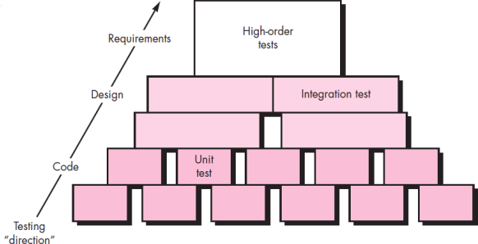

Figure 7.1 Unit Testing
Unit testing is the act of testing a unit in your application. A unit is often a function or a method of a class instance. The unit is also referred to as a “unit under test”. The goal of a single unit test is to test only some permutation of the “unit under test”. If you write a unit test that aims to verify the result of a particular code path through a Python function, you need only be concerned about testing the code that lives in the function body itself. If the function accepts a parameter that represents a complex application “domain object” (such as a resource, a database connection, or an SMTP server), the argument provided to this function during a unit test need not be and likely should not be a “real” implementation object. In computer programming, unit testing is a method by which individual units of source code, sets of one or more computer program modules together with associated control data, usage procedures, and operating procedures are tested to determine if they are fit for use. Intuitively, one can view a unit as the smallest testable part of an application. In procedural programming, a unit could be an entire module, but it is more commonly an individual function or procedure. In object-oriented programming, a unit is often an entire

interface, such as a class, but could be an individual method. Unit tests are short code fragments created by programmers or occasionally by white box testers during the development process. Unit testing focuses verification effort on the smallest unit of software design—the software component or module. Using the component-level design description as a guide, important control paths are tested to uncover errors within the boundary of the module.

Benefits of Unit testing:
- Find problems early
- Facilitates change
- Simplifies integration
- Documentation
- Design

Unit testing Limitations:
- Testing will not catch every error in the program, since it cannot evaluate every execution path in any but the most trivial programs. Additionally, unit testing by definition only tests the functionality of the units themselves. Therefore, it will not catch integration errors or broader system-level errors
- Another challenge related to writing the unit tests is the difficulty of setting up realistic and useful tests. It is necessary to create relevant initial conditions so the part of the application being tested behaves like part of the complete system.
- It is also essential to implement a sustainable process for ensuring that test case failures are reviewed daily and addressed immediately. If such a process is not implemented and ingrained into the team's workflow, the application will evolve out of sync with the unit test suite, increasing false positives and reducing the effectiveness of the test suite.
- Unit testing embedded system software presents a unique challenge: Since the software is being developed on a different platform than the one it will eventually run on, you cannot readily run a test program in the actual deployment environment, as is possible with desktop programs.

Integration Testing:
Integration testing (sometimes called integration and testing) is the phase in software testing in which individual software modules are combined and tested as a group. It occurs after unit testing and before validation testing. Integration testing takes as its input modules that have been unit tested, groups them in larger aggregates, applies tests defined in an integration test plan to those aggregates, and delivers as its output the integrated system ready for system testing. The purpose of integration testing is to verify functional, performance, and reliability requirements placed on major design items. These "design items", i.e. assemblages (or groups of units), are exercised through their interfaces using black box testing, success and error cases being simulated via appropriate parameter and data inputs. Simulated usage of shared data areas and inter-process communication is tested and individual subsystems are exercised through their input interface. Test cases are constructed to test whether all the components within assemblages interact correctly, for example across procedure calls or process

activations, and this is done after testing individual modules, i.e. unit testing. The overall idea is a "building block" approach, in which verified assemblages are added to a verified base which is then used to support the integration testing of further assemblages.
Integration testing is a systematic technique for constructing the software architecture while at the same time conducting tests to uncover errors associated with interfacing. The objective is to take unit-tested components and build a program structure that has been dictated by design. There is often a tendency to attempt non incremental integration; that is, to construct the program using a “big bang” approach.
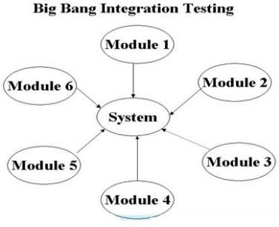
Figure 7.2 Big Bang Integration Testing
In big bang approach, all components are combined in advance. The entire program is tested as a whole. A set of errors is encountered. Correction is difficult because isolation of causes is complicated by the vast expanse of the entire program. Once these errors are corrected, new ones appear and the process continues in a seemingly endless loop. Incremental integration is the antithesis of the big bang approach. The program is constructed and tested in small increments, where errors are easier to isolate and correct; interfaces are more likely to be tested completely; and a systematic test approach may be applied. Generally, small software systems are integrated and tested in a single phase, whereas larger systems involve several integration phases to build a complete system, such as integrating modules into low-level subsystems for integration with larger subsystems. Integration testing encompasses all aspects of a software system's performance, functionality and reliability. The two main integration testing strategies are as follows:
- Top-Down: Involves testing the top integrated modules first. Subsystems are tested individually. Top-down testing facilitates detection of lost module branch links.
- Bottom-Up: Involves low-level component testing, followed by high-level components. Testing continues until all hierarchical components are tested. Bottom-up testing facilitates efficient error detection. Top-Down Testing:-

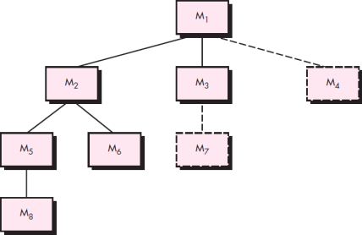

Figure 7.3 Top-down Integration Testing
Top-down integration testing is an incremental approach to construction of the software architecture. Modules are integrated by moving downward through the control hierarchy, beginning with the main control module (main program). Modules subordinate (and ultimately subordinate) to the main control module are incorporated into the structure in either a depth-first or breadth-first manner. Referring to Figure 17.5, depth-first integration integrates all components on a major control path of the program structure. Selection of a major path is somewhat arbitrary and depends on application-specific characteristics. For example, selecting the left-hand path, components M1, M2, M5 would be integrated first. Next, M8 or (if necessary for proper functioning of M2) M6 would be integrated. Then, the central and right-hand control paths are built. Breadth-first integration incorporates all components directly subordinate at each level, moving across the structure horizontally. From the figure, components M2, M3, and M4 would be integrated first. The next control level, M5, M6, and so on, follows.
The integration process is performed in a series of five steps:
- The main control module is used as a test driver and stubs are substituted for all components directly subordinate to the main control module.
- Depending on the integration approach selected (i.e., depth or breadth first), subordinate stubs are replaced one at a time with actual components.
- Tests are conducted as each component is integrated.
- On completion of each set of tests, another stub is replaced with the real component.
- Regression testing may be conducted to ensure that new errors have not been introduced. The process continues from step 2 until the entire program structure is built.

Bottom-Up Testing:-
Bottom up testing is an approach to integrated testing where the lowest level components are tested first, then used to facilitate the testing of higher level components. The process is repeated until the component at the top of the hierarchy is tested.

All the bottom or low-level modules, procedures or functions are integrated and then tested. After the integration testing of lower level integrated modules, the next level of modules will be formed and can be used for integration testing. This approach is helpful only when all or most of the modules of the same development level are ready. This method also helps to determine the levels of software developed and makes it easier to report testing progress in the form of a percentage.
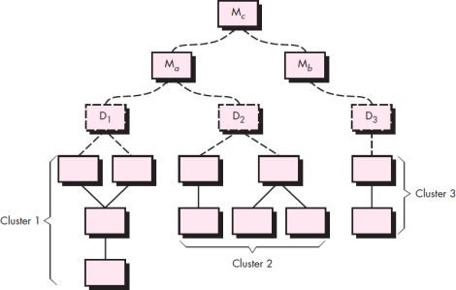

Figure 7.4 Bottom-up Integration
Bottom-up integration testing, as its name implies, begins construction and testing with atomic modules (i.e., components at the lowest levels in the program structure). Because components are integrated from the bottom up, the functionality provided by components subordinate to a given level is always available and the need for stubs is eliminated. A bottom-up integration strategy may be implemented with the following steps:
- Low-level components are combined into clusters (sometimes called builds) that perform a specific software sub-function.
- A driver (a control program for testing) is written to coordinate test case input and output.
- The cluster is tested.
- Drivers are removed and clusters are combined moving upward in the program structure. Components are combined to form clusters 1, 2, and 3. Each of the clusters is tested using a driver (shown as a dashed block). Components in clusters 1 and 2 are subordinate to Ma. Drivers D1 and D2 are removed and the clusters are interfaced directly to Ma. Similarly, driver D3 for cluster 3 is removed prior to integration with module Mb. Both Ma and Mb will ultimately be integrated with component Mc, and so forth. Limitation of Integration Testing:
  - Any conditions not stated in specified integration tests, outside of the confirmation of the execution of design items, will generally not be tested.
  - It is much slower than unit testing.
  - Be much harder or time consuming to recreate and run fully
  - Collecting the test result might be more problematic

Task 8

To perform various white box and black box testing techniques.

White box Testing – Software Engineering
White Box Testing, or glass box testing, is a software testing technique that focuses on the software’s internal logic, structure, and coding. It provides testers with complete application knowledge, including access to source code and design documents, enabling them to inspect and verify the software’s inner workings, infrastructure, and integrations.
Test cases are designed using an internal system perspective, and the methodology assumes explicit knowledge of the software’s internal structure and implementation details. This in-depth visibility allows White Box Testing to identify issues that may be invisible to other testing methods.

Objective of White Box Testing
White Box Testing serves a crucial role in software testing by allowing testers to inspect and verify the inner workings of a software system, including its code, infrastructure, and integrations.
The key objective of White Box Testing include:
- Thoroughness: It provides complete code coverage, ensuring every part of the software’s internal structure is tested.
- Automation: Test cases can be easily automated, saving time and resources.
- Optimization: It helps in code optimization by identifying hidden errors and redundancies.
- Introspection: It provides an in-depth understanding of the software, which can be invaluable for future development and maintenance.
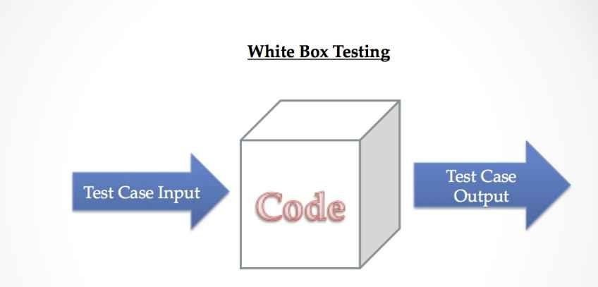
Figure 8.1- White Box testing

Why perform White Box Testing?

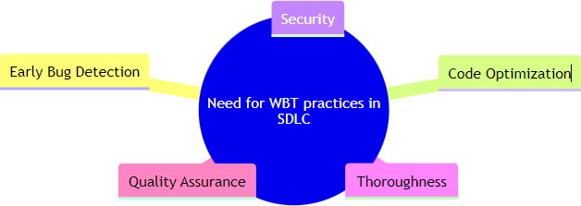
Figure 8.2 Technique of performing

White Box Testing practices are integral to the Software Development Life Cycle (SDLC) for several reasons:
- Early Bug Detection: White Box Testing allows for detecting bugs and errors early in development. This early detection can save time, effort, and resources, as fixing bugs later in the development process can be more complex and costly.
- Code Optimization: Identify redundant code and software areas that can be optimized. This leads to more efficient and streamlined software.
- Security: Uncover security vulnerabilities in the code. By examining the internal structure of the software, testers can identify potential security risks and ensure that security best practices have been followed.
- Thoroughness: It examines all the internal workings of the software. This thoroughness ensures that every part of the code is tested and validated, leading to robust and reliable software.
- Quality Assurance: White Box Testing is a critical part of ensuring software quality. By testing the software’s internal structure, White Box Testing ensures that the software functions as expected and meets the required standards.

Types Of White Box Testing
White box testing can be done for different purposes. The three main types are:
  - Unit Testing
  - Integration Testing
  - Regression Testing
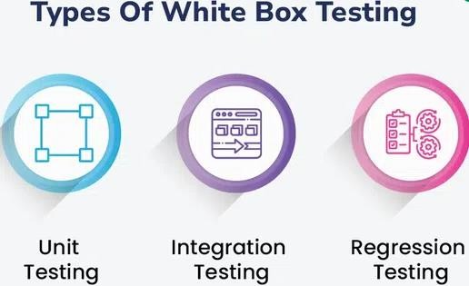
Figure 8.3- Types of White Box Testing

Unit Testing
Checks if each part or function of the application works correctly. Ensures the application meets design requirements during development.

Integration Testing
Examines how different parts of the application work together.
Done after unit testing to make sure components work well both alone and together.

Regression Testing
Verifies that changes or updates don’t break existing functionality. Ensures the application still passes all existing tests after updates.

White Box Testing Techniques
One of the main benefits of white box testing is that it allows for testing every part of an application. To achieve complete code coverage, white box testing uses the following techniques:

Statement Coverage
In this technique, the aim is to traverse all statements at least once. Hence, each line of code is tested. In the case of a flowchart, every node must be traversed at least once. Since all lines of code are covered, it helps in pointing out faulty code.
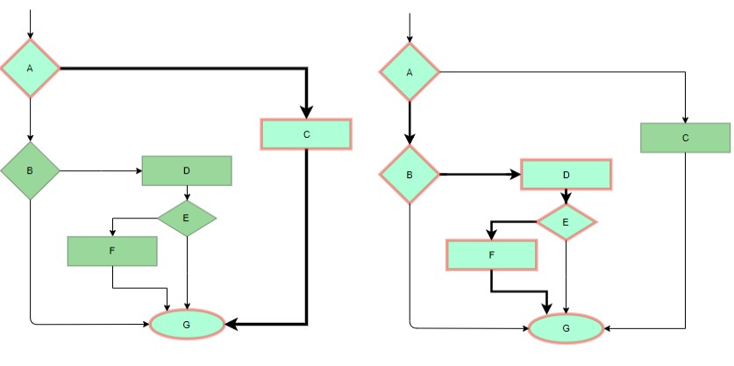
Figure 8.4 Statement Coverage

Branch Coverage
In this technique, test cases are designed so that each branch from all decision points is traversed at least once. In a flowchart, all edges must be traversed at least once.
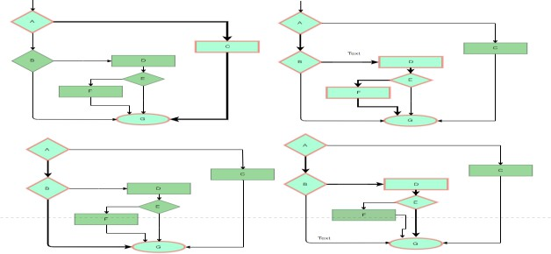
Figure 8.5 Branch Coverage

Condition Coverage
In this technique, all individual conditions must be covered as shown in the following example:
READ X, Y
IF(X == 0 || Y == 0) PRINT ‘0’
#TC1 – X = 0, Y = 55 #TC2 – X = 5, Y = 0

Multiple Condition Coverage
In this technique, all the possible combinations of the possible outcomes of conditions are tested at least once. Let’s consider the following example:
READ X, Y
IF(X == 0 || Y == 0) PRINT ‘0’
#TC1: X = 0, Y = 0 #TC2: X = 0, Y = 5 #TC3: X = 55, Y = 0 #TC4: X = 55, Y = 5

Basis Path Testing
In this technique, control flow graphs are made from code or flowchart and then Cyclomatic complexity is calculated which defines the number of independent paths so that the minimal number of test cases can be designed for each independent path. Steps:
Make the corresponding control flow graph Calculate the cyclomatic complexity
Find the independent paths
Design test cases corresponding to each independent path
V(G) = P + 1, where P is the number of predicate nodes in the flow graph
V(G) = E – N + 2, where E is the number of edges and N is the total number of nodes V(G) = Number of non-overlapping regions in the graph

#P1: 1 – 2 – 4 – 7 – 8
#P2: 1 – 2 – 3 – 5 – 7 – 8
#P3: 1 – 2 – 3 – 6 – 7 – 8
#P4: 1 – 2 – 4 – 7 – 1 – . . . – 7 – 8

Loop Testing
Loops are widely used and these are fundamental to many algorithms hence, their testing is very important. Errors often occur at the beginnings and ends of loops.
Simple loops: For simple loops of size n, test cases are designed that: Skip the loop entirely
Only one pass through the loop 2 passes
m passes, where m < n n-1 ans n+1 passes
Nested loops: For nested loops, all the loops are set to their minimum count, and we start from the innermost loop. Simple loop tests are conducted for the innermost loop and this is worked outwards till all the loops have been tested.
Concatenated loops: Independent loops, one after another. Simple loop tests are applied for each. If they’re not independent, treat them like nesting.

Black Box Testing – Software Engineering

Black box testing is a software testing technique where the internal workings or code structure of the system being tested are not known to the tester.
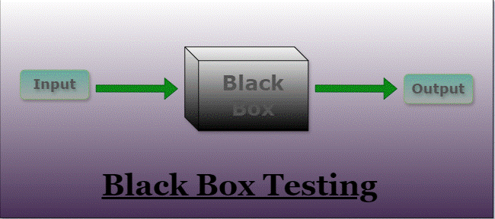
In other words, the tester focuses solely on the external behaviour of the software, without having access to its internal source code. The name “black box” comes from the idea that the internal workings are hidden or “boxed” from the tester’s view.
Figure 8.6 Black Box Testing

Key characteristics of black box testing include:
- Independent Testing: Black box testing is typically performed by testers who are independent of the development team. This ensures a fresh perspective and helps identify issues that developers might overlook.
- Requirements-Based Testing: Testers design test cases based on the software’s
requirements and specifications, without being concerned about how the code is implemented.
- Functional Testing: The main goal of black box testing is to assess the
functionality of the software, checking if it meets the expected behaviour and delivers the desired outputs for various inputs.
- No Knowledge of Internal Code: Testers do not have access to the source code,
architecture, or design details of the software. They interact with the system through its user interfaces or APIs.

Types Of Black Box Testing
The following are the several categories of black box testing:
- Functional Testing
- Regression Testing
- Nonfunctional Testing (NFT)

Functional Testing
Functional testing is defined as a type of testing that verifies that each function of the software application works in conformance with the requirement and specification.
This testing is not concerned with the source code of the application. Each functionality of the software application is tested by providing appropriate test input, expecting the output, and comparing the actual output with the expected output.
This testing focuses on checking the user interface, APIs, database, security, client or server application, and functionality of the Application Under Test. Functional testing can be manual or automated. It determines the system’s software functional requirements.

Regression Testing
Regression Testing is the process of testing the modified parts of the code and the parts that might get affected due to the modifications to ensure that no new errors have been introduced in the software after the modifications have been made.
Regression means the return of something and in the software field, it refers to the return of a bug. It ensures that the newly added code is compatible with the existing code.
In other words, a new software update has no impact on the functionality of the software. This is carried out after a system maintenance operation and upgrades.

Non functional Testing
Non-functional testing is a software testing technique that checks the non-functional attributes of the system.
Non-functional testing is defined as a type of software testing to check non-functional aspects of a software application.
It is designed to test the readiness of a system as per non functional parameters which are never addressed by functional testing.
Non-functional testing is as important as functional testing.
Non-functional testing is also known as NFT. This testing is not functional testing of software. It focuses on the software’s performance, usability, and scalability.

Black Box Testing Techniques
Black Box Testing offers several effective techniques for ensuring comprehensive test coverage and efficient testing strategies. Here are three prominent techniques widely used in this testing:

Equivalence Class Testing:
This technique aims to streamline the number of test cases while maintaining adequate coverage. It involves categorizing input data into equivalence classes, where each class represents a group of similar inputs that should elicit the same system behavior. By testing only one representative from each equivalence class, testers can verify that the software behaves consistently across the entire group, reducing the number of required test cases.

Boundary Value Testing:
Focused on values at the boundaries of input ranges, this technique assesses whether a system handles values at the extremes of acceptable ranges correctly. By testing values like the minimum, maximum, and just beyond these boundaries, testers can uncover potential issues related to boundary conditions. This method is particularly useful when inputs are expected to fall within specific ranges, such as age limits or numerical constraints.

Decision Table Testing:
Decision Table Testing employs a structured matrix format to represent the relationship between input conditions and their corresponding outcomes. Each column in the table represents a unique combination of conditions and their associated results. This technique is especially valuable for systems with complex conditional logic. Testers can use decision tables to systematically assess how various combinations of inputs influence the software’s behaviour, ensuring comprehensive test coverage.
These testing techniques offer valuable strategies for assessing software functionality from the outside, without needing to examine its internal code. By strategically applying these techniques, testers can efficiently identify defects and ensure that the software meets specified requirements and specifications.

Task 9

Testing of A Web Site.

Website Testing
Website Testing refers to testing end-user scenarios on a website to test its behavior. These end-user scenarios are scripted by QAs using an automation framework to mimic user interactions on a website’s UI. QAs can also follow a written test plan that describes a set of unique test scenarios under manual website testing.
For example, a test script can be written to test a website’s Login page. This script will verify if the Username and Password fields accept appropriate inputs and check whether the Login was successful.

To testify to this, let’s look at some statistics that signify why testing of a website
is critical:
- One in three customers will stop interacting with a specific website if they encounter a bad user experience.
- 57% of users do not recommend a business without a good mobile website design.
- 88% of online customers said they are less likely to return to a website if they’ve had a negative experience in the first place.

Types of Website Testing
Several types of website testing serve different purposes in providing a high-quality user experience. Here are some common types of website testing:
- Functionality Testing: This type of testing focuses on checking if all the features and functionalities of the website are working as intended.
- Usability Testing: assesses how user-friendly and intuitive the website layout,
design, and overall UX is.
- Compatibility Testing: ensures the website functions correctly across different device-browsers-OS combinations with any inconsistencies in rendering or behavior.
- Cross-Browser Testing: Cross-browser testing is crucial as it ensures the website
looks and functions correctly across browsers like Chrome, Firefox, Safari, and Edge. It’s important to test web pages in multiple browsers to guarantee consistent performance and user experience.
- Responsive Testing: This testing ensures that the website’s layout and design adapt
appropriately to different screen sizes and devices, providing a consistent user experience across desktops, tablets, and smartphones.
- Accessibility Testing: evaluates whether the website is usable by individuals with
disabilities. QA checks if the website adheres to accessibility standards under WCAG testing.

- Performance Testing: evaluates the website’s speed, responsiveness, and overall
performance.
- User Acceptance Testing (UAT): UAT involves having end-users test the website to validate that it meets their requirements and expectations.
- Regression Testing: Regression testing involves retesting the website after making

changes or updates to ensure that new features or fixes don’t introduce new issues or break existing functionalities.
- Localization Testing: If the website is designed to be used in multiple languages or
regions, localization testing checks if the content, formatting, and functionality work correctly for each specific locale.

How To Perform Website Testing

Ensure Cross Browser Compatibility
Each browser has its rendering engine. Moreover, rendering engines might also differ for different browser versions. There’s a high probability of a website rendering uniquely across distinct browsers. In simple terms, a website’s appearance may get inconsistent across distinct browsers or browser versions.
  - To avoid these inconsistencies in the viewing experience, QAs must thoroughly perform cross-browser testing for their websites.
  - This will help teams optimize the website’s viewing experience for all the leading browsers and fix rendering issues appearing for specific browsers.
  - A tool like Browser Stack can be convenient in such a case as it instantly empowers QAs to run cross-browser tests across 3000+ real device browser combinations.
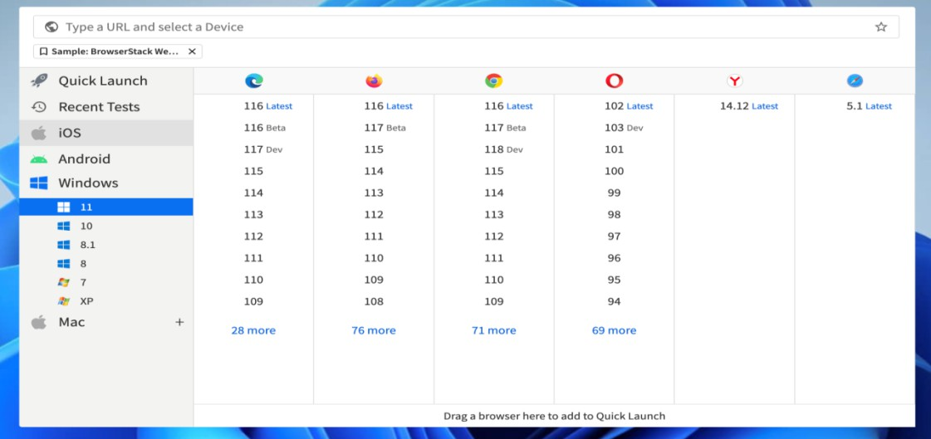
Figure 9.1 Ensure Cross Browser Compatibility

Test for Responsiveness
A responsive layout enables websites to resize themselves dynamically per the screen sizes in which it is viewed. Nearly 60% of incoming website traffic comes from mobile devices.

- Mobile users can not be ignored.
- Developers must ensure that their websites are mobile responsive, so that end users have an optimal viewing experience across diverse screen resolutions.
- A mobile-responsive design is essential because Google has moved to a mobile-first indexing algorithm.
- This means opting for a responsive design elevates your SEO efforts.
- However, it is critical to remember that responsive design can also introduce issues, such as misaligned buttons or links that are difficult to tap.
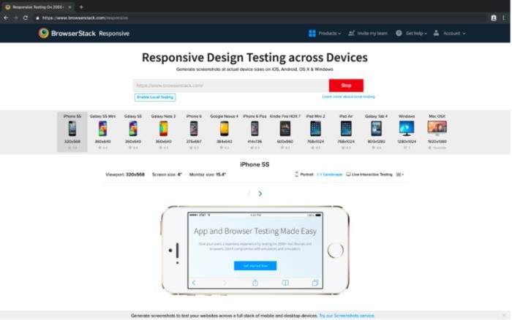
- To fix those issues in advance, it is ideal to use an online responsive design checker tool that helps you view your websites across distinct device types (mobiles, tablets, desktops).

Figure 9.2 Test for Responsiveness

Functionality Testing
This is the most fundamental yet critical website QA testing phase, where the QA team must thoroughly test all the UI elements considering maximum use case scenarios.

Validating the UI elements includes testing:
- Forms for data input validity and login procedure
- Text fields
- CTAs
- Dropdowns
- Header navigation and search box
- Critical user flow
- Formatting and spacing
Testing all the above elements manually might be convenient for a smaller website. However, comprehensive UI testing for larger websites is a daunting task. Teams must prefer test automation tools like Selenium to run automated parallel tests. It helps validate UI functionalityfaster.
BrowserStack empowers QAs to run manual and automated UI tests using tools like Selenium on its real device cloud for testing at scale in real user conditions. Leveraging such a platform can help teams achieve their test goals faster and release a full website faster.

Check for Broken Links
Broken links create an extremely frustrating experience for website visitors, particularly when searching for crucial information. Moreover, broken links also adversely affect the SEO of a website. Naturally, QAs must pay close attention to ensuring all links are directed toward the intended landing pages or documents.

- Teams can use online speed optimization plugins to identify and fix broken links.
- Once a broken link is traced, it is imperative to add the appropriate link or a redirect to send the visitors to the intended page.
- Beyond this, QAs must verify that the key links are directed to the intended page (even if they aren’t broken). For example, testing all the header navigation links to ensure they go to the intended landing pages.

Ensure Security
In online business, websites may request personal information, especially when developing e-commerce websites. As part of your QA checklist, security testing is paramount.
- Ensure that your website’s SSL certificate is in place to protect sensitive user information.
- This helps establish secure connections as the data is encrypted to prevent hacker attacks.
- Leading credit card companies and payment gateway integrations will require this as a mandate for checkout pages.
- One must also ensure that all the HTTP traffic is redirected to the HTTPS version of your site.
- BrowserStack security is SOC2 Type 2 compliant, and our privacy policy complies with the GDPR.
- HTTPS is a default implementation at BrowserStack.
Every time you communicate with us, you are redirected through secure TLS (Transport Layer Security)

Test Payment Gateways
The digital advancements in the world of exchanging payments have made it convenient for websites to accept payments online. For swift transactions, teams must thoroughly test the integrations with their payment solutions provider to ensure customers do not face online payment challenges.
An ideal way of testing this would be to make dummy payments in a sandbox environment to test all payment modes and have all the necessary test cases created beforehand.

Cookie Testing
Cookies are text files in the user’s browser. These text files contain specific end-user information, such as login information, cart details, visited pages, IP address, etc. For example, if you log in to a site, that site will add a cookie for your login session. This cookie

is later used for various purposes like personalizing content for a returning web user, sending personalized ads, etc.
- One must test their website across multiple user scenarios to evaluate their website’s behavior with cookies enabled or disabled.
- Testing the website across leading browsers in real user conditions using a real device cloud is the best way QAs can ensure that everything works as intended.

Website Testing Tools
To balance and complement manual testing, it is crucial to start automating testing procedures as soon as feasible. Without the use of automation, and comprehensive website testing tools, the job of a QA becomes challenging.
- BrowserStack: BrowserStack is an industry-leading testing infrastructure that offers powerful manual and automation testing capabilities to analyze your website across browsers and devices.
- Selenium: Selenium is an automation framework that supports multiple programming languages such as Java, Javascript, C#, Python, Ruby, etc. It supports all major browsers Chrome, Edge, Firefox, and Safari along with multiple operating systems: Windows, Mac, and Linux-based OS.
- Cypress: Cypress testing is more reliable and faster as there is no browser driver concept in Cypress. It interacts with the browser, so tests are faster and more stable.
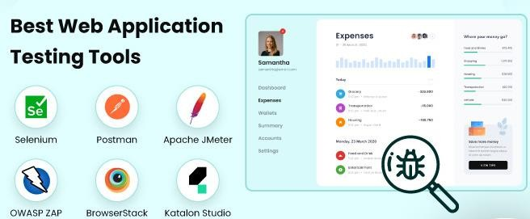
- Playwright: Playwright is an Open source tool. However, it is attached to the Microsoft brand and is considered one of the pioneers in headless browser testing, making it popular. It supports multiple browsers such as Chromium, Firefox, Edge, Chrome, and Safari(Webkit releases only)

Figure 9.3 Website Testing Tools

